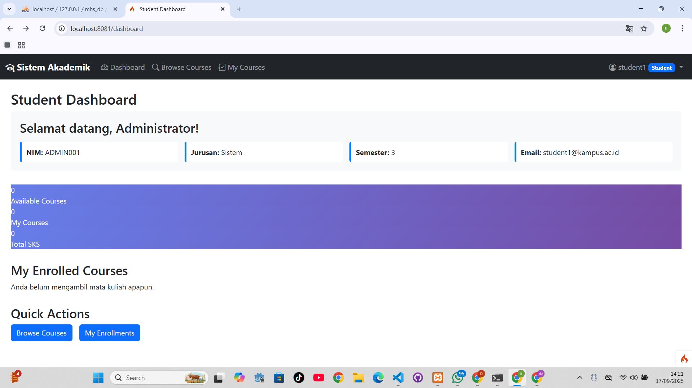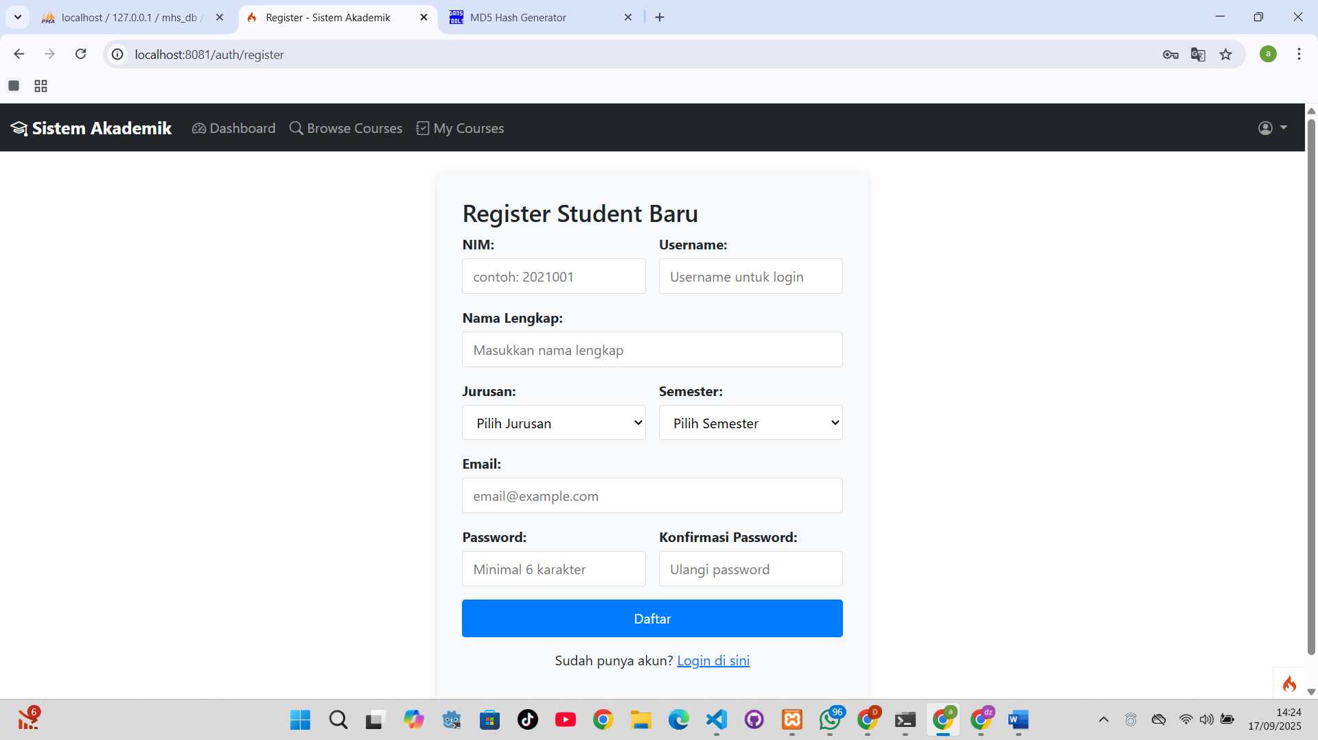

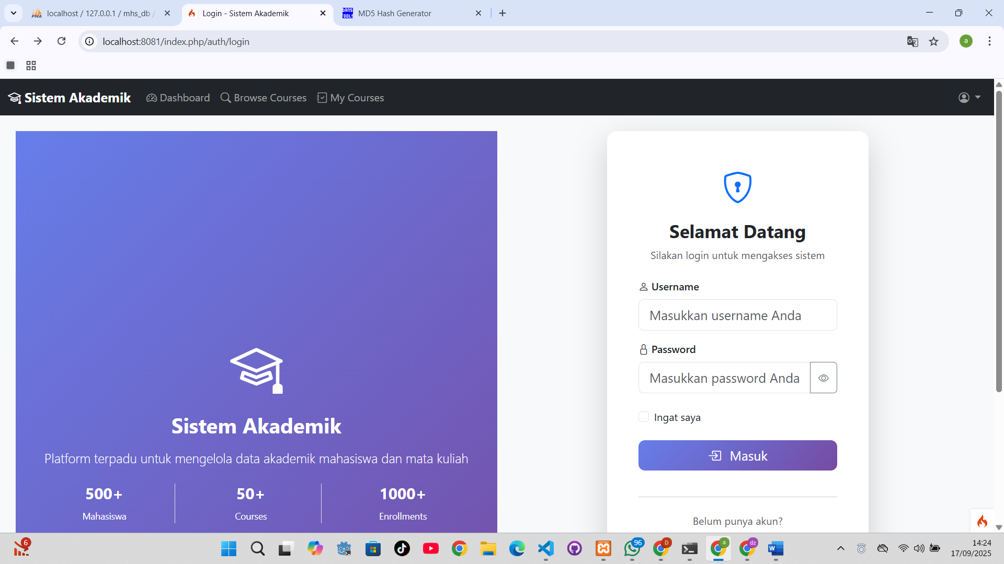

Masih dalam tahap pengembangan!

Main Github developing : <https://github.com/dzhax499/website-CRUD-ci4>

Folder main on screenshot : https://github.com/dzhax499/website-CRUD-ci4/tree/main/Misson-3-CI-Composer